Technical Documentation
E-Commerce Platform (Full-Stack Project)

1. Project Description
This project is a full-stack E-commerce web application built using modern web technologies.
It simulates a real-world online store where users can browse products, view details, and manage a shopping cart.
The system also includes an Admin panel that allows product management through secure authentication.

Project Objectives
- Build a responsive online store
- Apply frontend and backend development skills
- Implement RESTful APIs
- Handle dynamic data using a database
- Simulate a real business environment

Technologies Used
Frontend:
- React.js
- Vite
- Tailwind CSS
- Axios
- React Router DOM
- Local Storage
- Fake API Data

2. Setup Instructions
Frontend Setup
- Navigate to frontend folder:
cd frontend
- Install dependencies:
npm install
- Start development server:
npm run dev

3. Folder Structure
Frontend Structure:
- components/ → Reusable UI components
- pages/ → Main pages (products, cart, admin)
- context/ → State management (cart, theme)
- App.jsx → Main app
- main.jsx → Entry point

4. Main Files Explanation
5. API Overview
Products:
- GET /api/products
- GET /api/products/:slug
- POST /api/products
- PUT /api/products/:id
- DELETE /api/products/:id
Categories:
- GET /api/categories
Authentication:
- POST /api/login

🎨 7. Features
User:
- Browse products
- View product details
- Add/remove items from cart
- Responsive design
Admin:
- Login system
- Manage products (CRUD)
- Protected dashboard

Website Pages Preview
- Hero Section
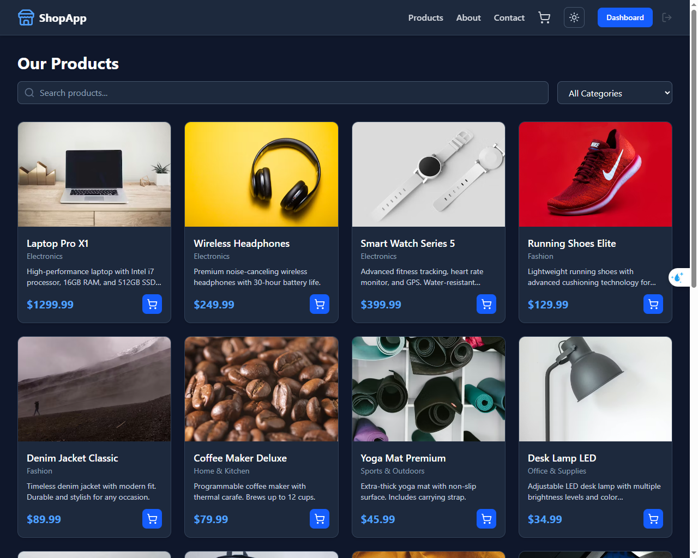
- About Page
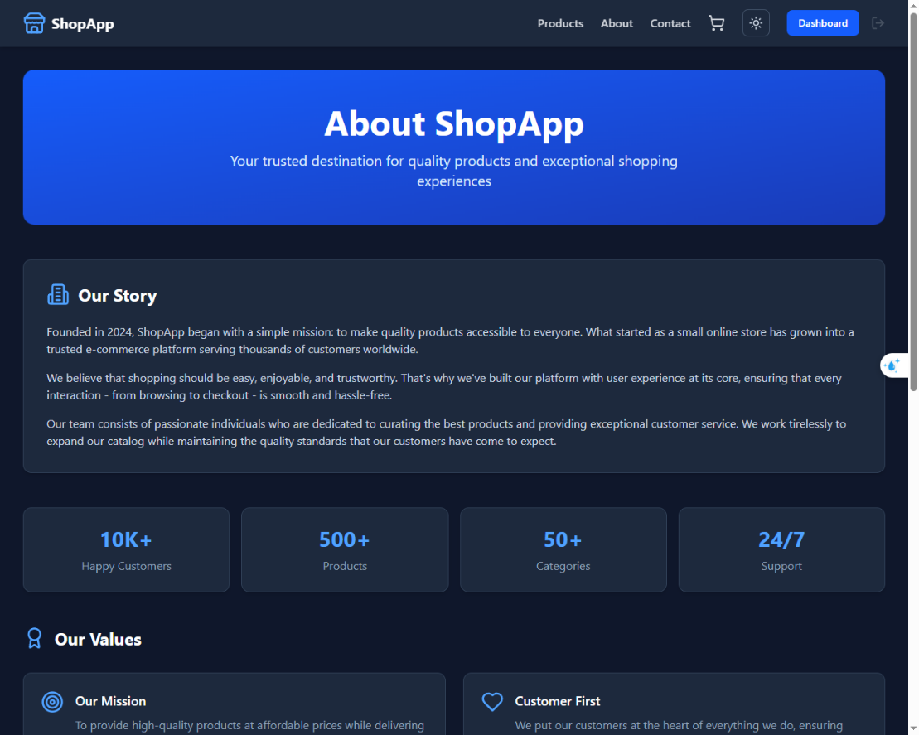
- Contact Page
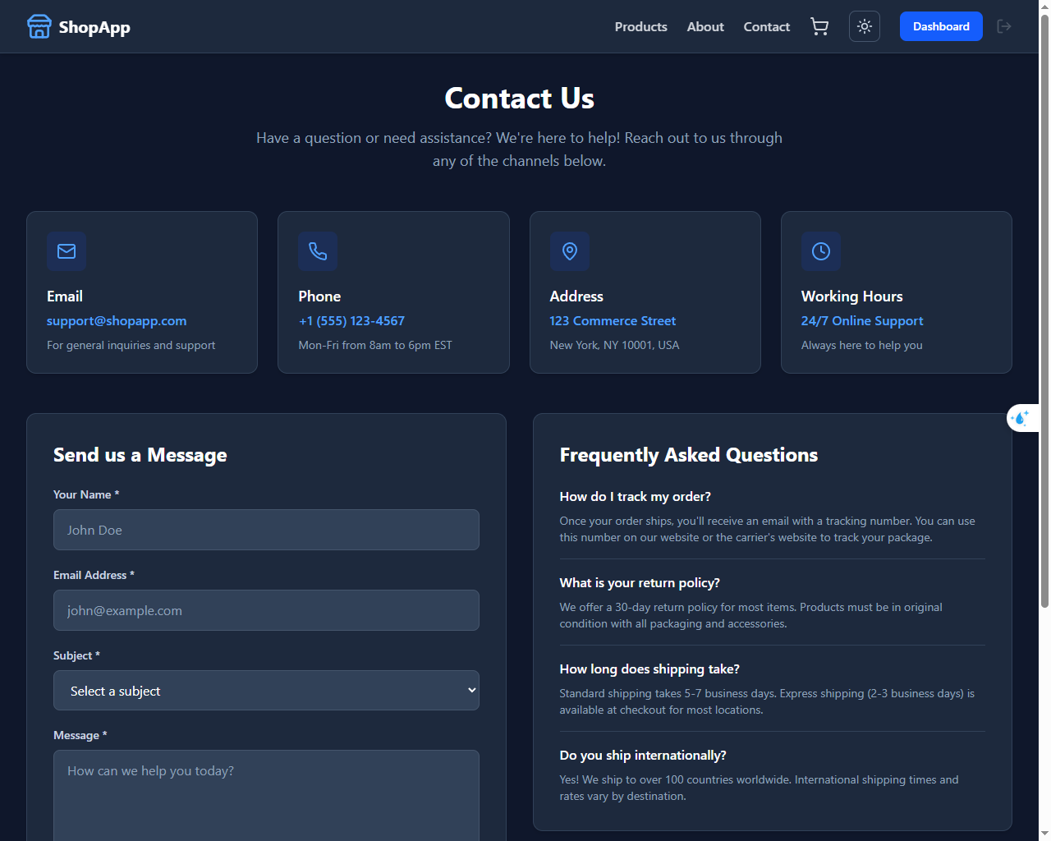
- Cart Shopping
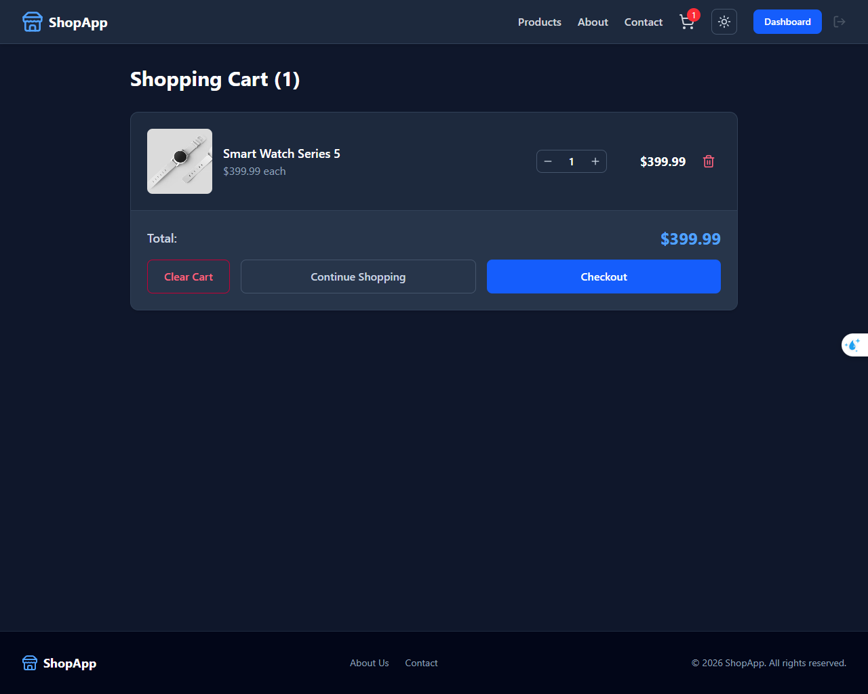
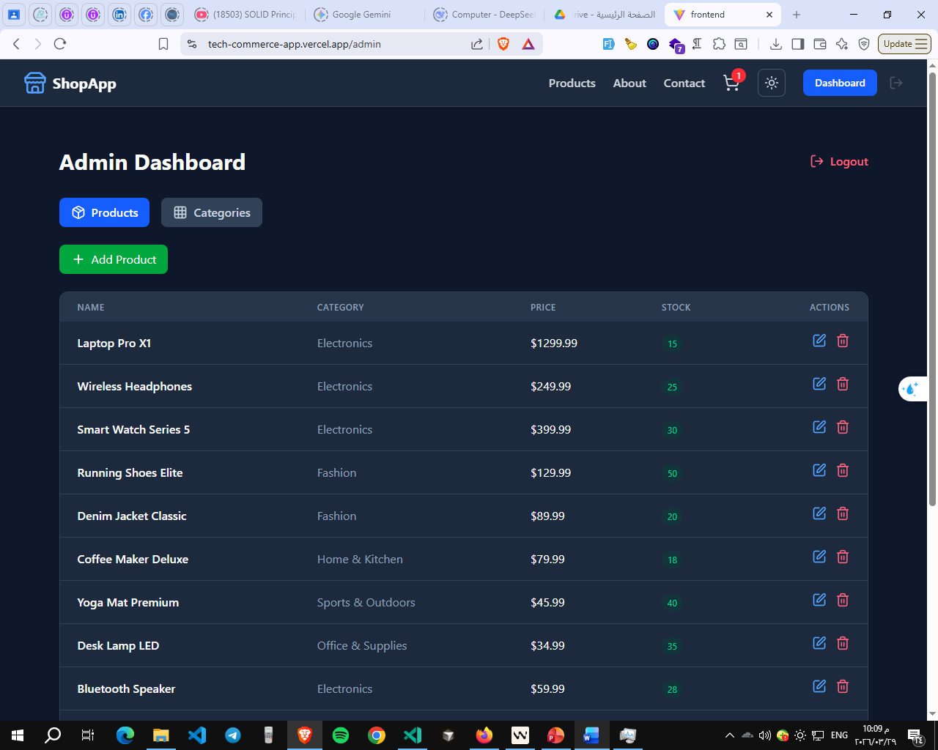
- Admin Dashboard Page

8. Challenges & Solutions
- Challenge 1: Managing state without backend
- Solution: Used React Context API and local Storage for persistence

- Challenge 2: Authentication without real server
- Solution: Simulated auth system using local Storage and protected routes

- Challenge 3: Component reusability
- Solution: Built modular and reusable components for scalability

- Challenge 4: UI responsiveness
- Solution: Used Tailwind CSS with mobile-first approach

- Challenge 5: Deployment issues
- Solution: Switched to frontend-only architecture using fake APIs

Reflects:
This project helped me understand:
• How to build a real-world web application from scratch
• How frontend and backend communicate using APIs
• The fundamentals of RESTful API design
I also improved my problem-solving skills and learned how to structure clean, maintainable, and scalable code.

This experience gave me more confidence in building full applications and thinking like a professional developer.
10. Conclusion
This project successfully demonstrates the ability to build a complete E-commerce platform using modern web technologies.
It covers both frontend and backend development and simulates real-world business logic.

Prepared by: Ahmad Abdallah
Date: March 2026

